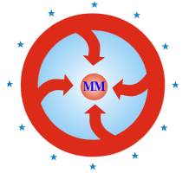

Macedonian Marketing Association „MARKETING“ - Skopje

Macedonian International Journal of Marketing

AUTHOR’S STATEMENT

Under the full moral and substantive responsibility, I/We declare that the paper titled ____________________________________________________________, which has been submitted for publication to the Editorial Board of the Macedonian International Journal of Marketing Volume V, Number 2:

- Is a result of individual research conducted in an ethical and responsible manner that comply with the relevant legislation;
- The results are presented, honestly and without fabrication, falsification or inappropriate data manipulation;
- The paper has not been published or accepted for publication elsewhere;
- All authors have significantly contributed to research.

Permission notice

Authors are expected to obtain permission from copyright holders for reproducing any illustrations, tables, figures or lengthy quotations previously published elsewhere. The Journal will not be held accountable for any copyright infringement caused by the authors.

Copyright notice

The content offered in the Journal remains the intellectual property of the authors and their publishers respectively. Macedonian Marketing Association „MARKETING” Skopje, R. North Macedonia keep the right to promote and re-publish the texts.

Date____________________
Author (s) Signature

1.__________________________
2.__________________________
3.__________________________
4.__________________________

Contact information
Name and surname:
Institution:
E-mail:

The signed Author’s Statement shall be forwarded in PDF format to the following e-mail address: aleksa.stamenkovski@gmail.com (journal e-mail, or manager editor e-mail)

